Contents
Background 1
Configuration 1
Menu Profile 1
Menu Options 2
Organisational Role 3
GDPR Control Parameters 5
GDPR Statutory Years for Deletion 5
Cleardown Days for GDPR Requests 5
Create a Subject Access Request 6
Download Subject Access Request Files 8
Process a Right to be Forgotten request 9
Request Failure 10
Request Success 11
Deleting GDPR Requests 11
Reporting on GDPR via Insight 11

Background
The GDPR Request Centre can be made available to users to complete the following employee requests:
Subject Access Requests – Any employee has the right to request a copy of the personal data the organisation has stored about them in a “structured commonly used and machine-readable format”. The GDPR Request Centre provides this data in both a CSV file and a machine-readable JSON file.
JSON – JavaScript Object Notation is an open-standard file format that uses human-readable text to transmit data objects consisting of attribute-value pairs and array data types. JSON is a language-independent data format.
Right to be Forgotten Requests – Any employee has the right to be forgotten as per GDPR guidelines. It is the responsibility of the organisation to carry out any due diligence and internal processes in relation to this request.

Configuration
A combination of user security requirements are needed, this includes a menu profile and an organisation role.

Menu Profile
Within the Security module, create a new Menu Profile.
Navigate via Security > Menu Profiles > click the Create new Profile button.
Add the Code and Description and click Add Profile to save
Code = GDPR
Description = GDPR
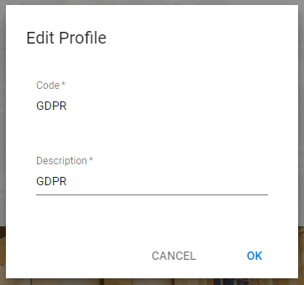
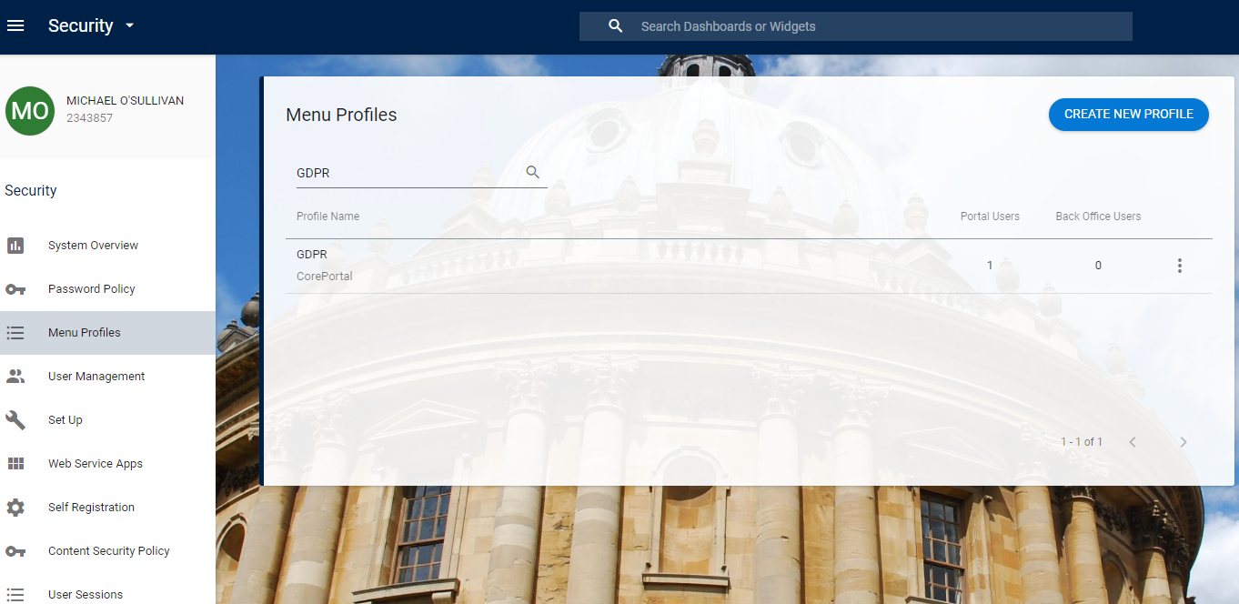

Menu Options
Assign Menu Options to the newly created Menu Profile via Security > Menu Profiles > search for the Menu Profile GDPR, click on the ellipses button and select Update Menu Options. Select the system area ‘CorePortal’. Search for the menu options and select using the Enabled indicator.
Users require a menu option to see the GDPR Requests in the Dashboard and to see the Core GDPR business area in Insight:
Menu Options are:
- GDPR Requests
- Coreportal – InsightArea GDPR

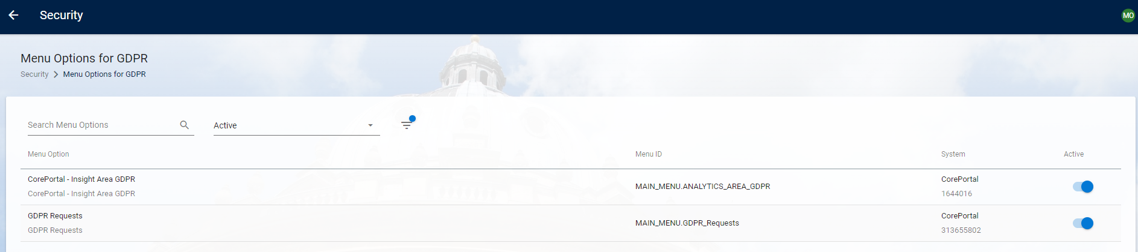
Assign the menu profile to the individual via PeopleXD > Security > User Management
Search for the individual user. Click on Ellipses > Manage Account > Menu Profiles
Locate the GDPR menu profile and enable the active indicator.
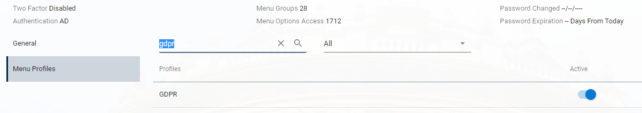

Organisational Role
A user needs to be assigned an Organisational Role in order to be able to see employee records on the GDPR Request Centre and within the Insight Reports.
There is a standard Org Role provided by The Access Group ‘GDPR Organisational Role’ and this needs to be assigned at Company access level.
Firstly, the Org Role needs to be activated. Navigate via People Management > Data Centre > References Data > Open> Organisational Role Types> filter by the GDPR role type and enable the active indicator.
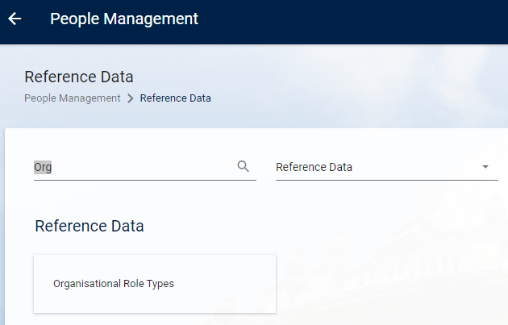
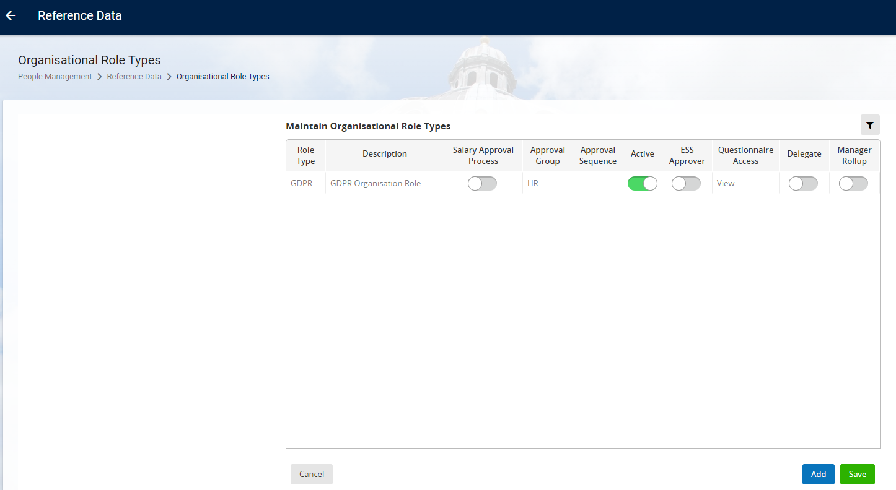
You then need to define the org group that access is aligned to. This will either be at Company or Department level. It is only possible to define one level in PeopleXD by which employees will be grouped e.g. If set to Department, each department needs to be assigned to a user to ensure that all employees can be managed in the GDPR Request Centre. A mix of levels is not possible.
Navigate to Administrator Dashboard > Admin > Admin Settings > search for the following parameter: gdpr_org_group.
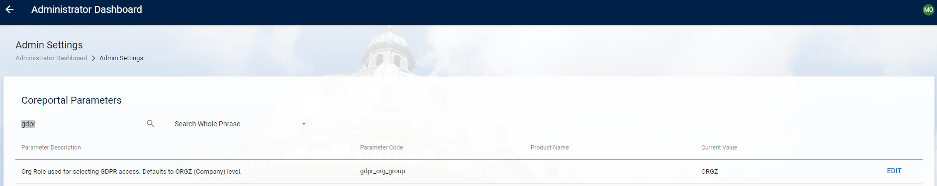
Click on the Edit button and set the required Org Level by entering the required code e.g. ORGZ (Company level). Click Save.
Assign the Org Role to the Employee
People Management > Data Centre > People Management > Maintain Organisational Role by Person.
Search for the user employee record in the Personnel No field.
Click Add to create a new row and update as follows:
Role | GDPR Organisation Role
Org Group | Company
Date From | The date the org role is assigned from.
Date To | The date after which the role is no longer assigned to the employee.
Org Group Item Code | 10 (Company)

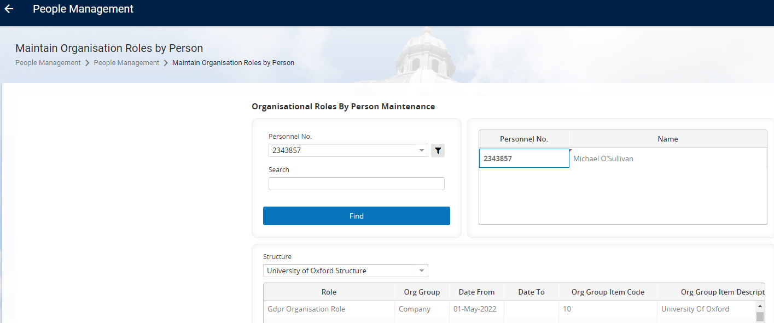

GDPR Control Parameters

GDPR Statutory Years for Deletion
When a deletion request is being processed, there is validation to prevent this occurring if the employee’s leave date is less than a specified number of years. This is defaulted to 7 years; however, this is configurable.
To manage the setting navigate via
Administrator Dashboard > Admin > Admin Settings > search for parameter gdpr_statutory_years.
Click on the Edit button and enter the required number of years. Click Save.
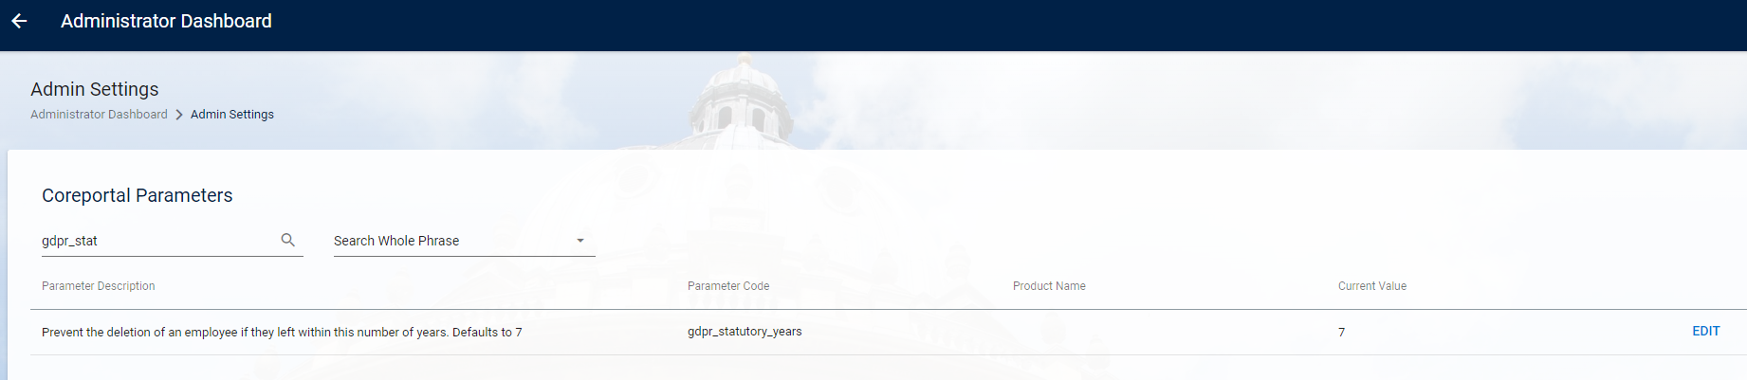

Cleardown Days for GDPR Requests
GDPR request history for ‘query’ requests is automatically cleared down on the GDPR Request Centre after a specified number of days. This is defaulted to 30 days; however, this is configurable.
To manage the setting navigate via
Administrator Dashboard > Admin > Admin Settings > search for parameter gdpr_cleardown_days.
Click on the edit button and enter the required number of days. Click Save.
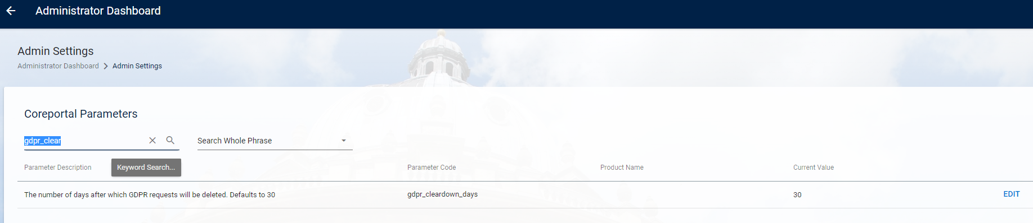

Create a Subject Access Request
The Subject Access Request is managed via the GDPR Requests Centre.
Navigate via Administration Dashboard > Admin > GDPR Requests > Open:
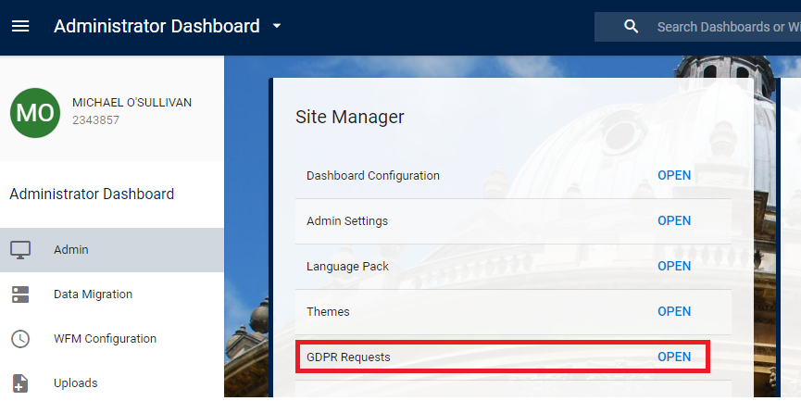
Click on the New Requests button, to open the ‘Create New Request’ screen
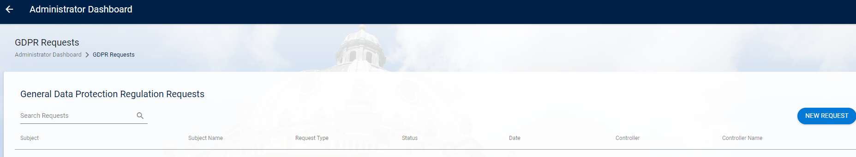
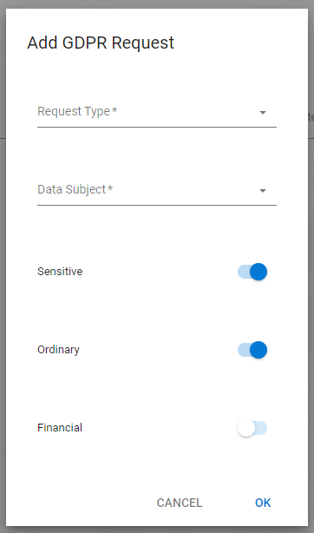

To create the Subject Access Request complete the fields as follows:
Request Type | Data Provision
Data Subject | Search for the employee by forename, surname or employee number.
Filter Setting – Ordinary | On by default.  This is standard personal information data e.g. employee number, name, address etc.
Filter Setting - Sensitive | On by default.  This refers to special categories of personal data e.g. ethnic backg4round, sexual orientation etc.
Filter Setting - Financial | Off by default.  This is the data subjects financial information e.g. payroll history.

Click OK.
The following confirmation message is displayed. Click Yes to fully submit the request. If you click No the request is not submitted.
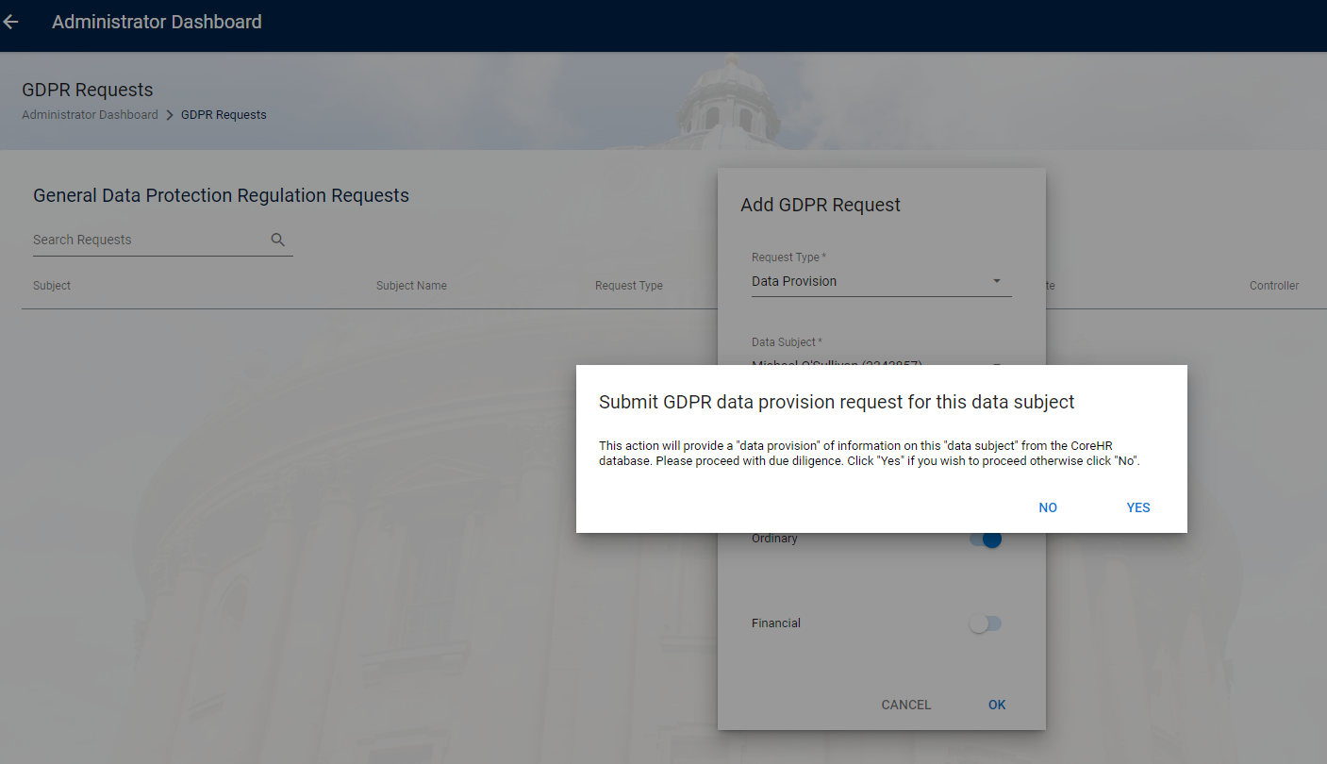
Once a request has been successfully submitted, it is listed on the GDPR Requests screen with a status of “OPEN” and a request type of “QUERY”.
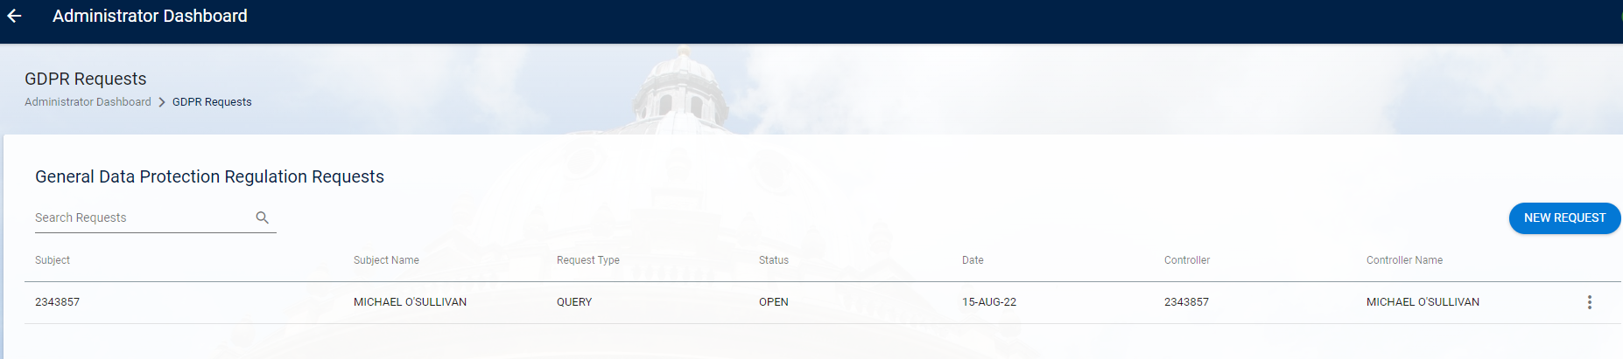
The request can take some time to process depending on the record and is based on the range of data and volume recorded for that employee on PeopleXD.
When the processing begins, the status updates on the GDPR Requests screen to “PROCESSING”.
The status updates to “CLOSED” once fully completed. The information requested for the data subject is now available to download.

Download Subject Access Request Files
To download the Subject Access Request output files for the employee navigate to the GDPR Request Centre via Administration Dashboard > Admin > GDPR Requests > Open.
The completed Subject Access Request will be displayed on this screen. You can use the search requests facility where multiple exist.
Click on the Ellipses button and select the option Documents.
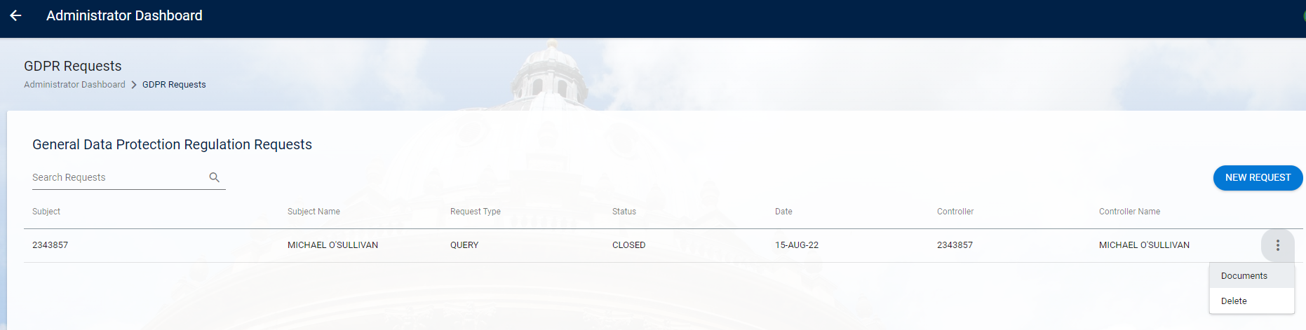
The GDPR Documents screen opens and all of the files produced as part of this request are listed on screen. The same report is available in two formats a csv and a json file.
Click the Ellipses button for the required file and select Download.
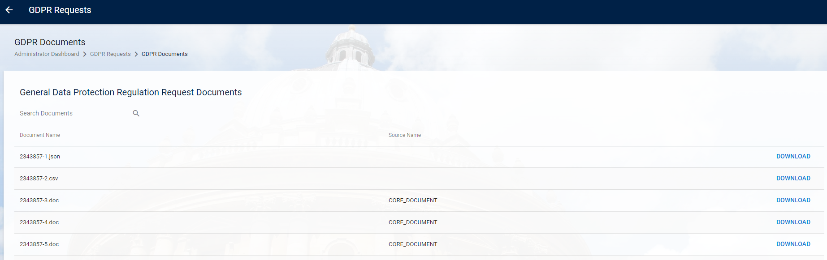
If there are any files for the employee on PeopleXD, these are listed on this GDPR Documents screen. These can be differentiated from the GDPR report files as these include a source name.

Process a Right to be Forgotten request
The Right to be Forgotten request is managed via the GDPR Requests Centre.
Navigate via Administration Dashboard > Admin > GDPR Requests > Open:

Click on the New Requests button, to process the Delete Request.

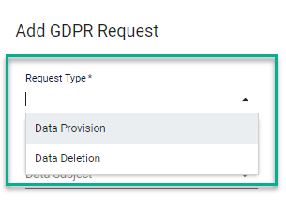
Complete the fields as follows:
Request Type | Data Deletion
Data Subject | Search for the employee by forename, surname or employee number.
Filter Settings | These are all not applicable for this request.

Click OK. Three warning messages are then displayed in turn which need to be responded to fully submit the deletion request.
First warning:
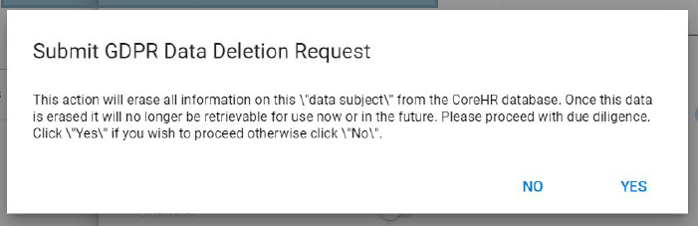
Second warning:
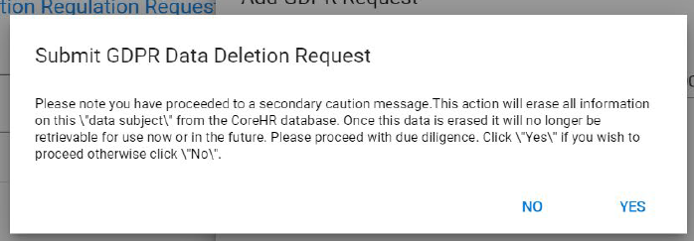
Third warning:
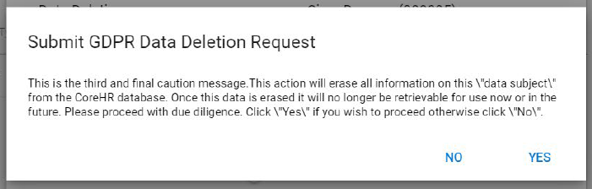
If No is selected for any of the warning messages the request is not submitted.
Once Yes is selected for all three warnings the request is fully submitted.
Once a request is successfully submitted, it is listed on the GDPR Requests screen with a status of “OPEN” and request type “DELETE”.
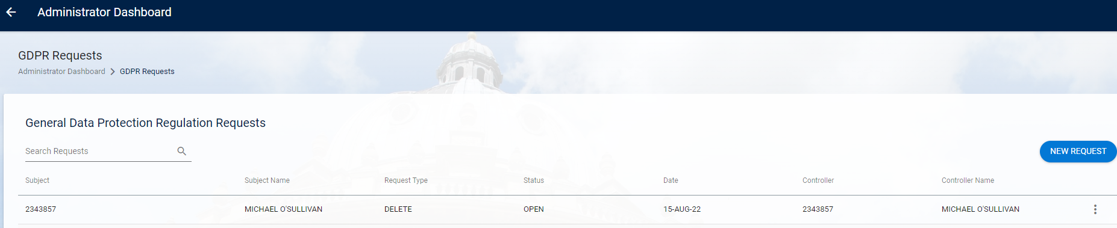

Request Failure
The request is listed on the GDPR Requests screen with a status of “DELETE NOT ALLOWED”.
An employee record may only be deleted if:
- The employee is a leaver
- Their leave date is more than 7 years ago.
The employee record is not deleted for a request with this status.
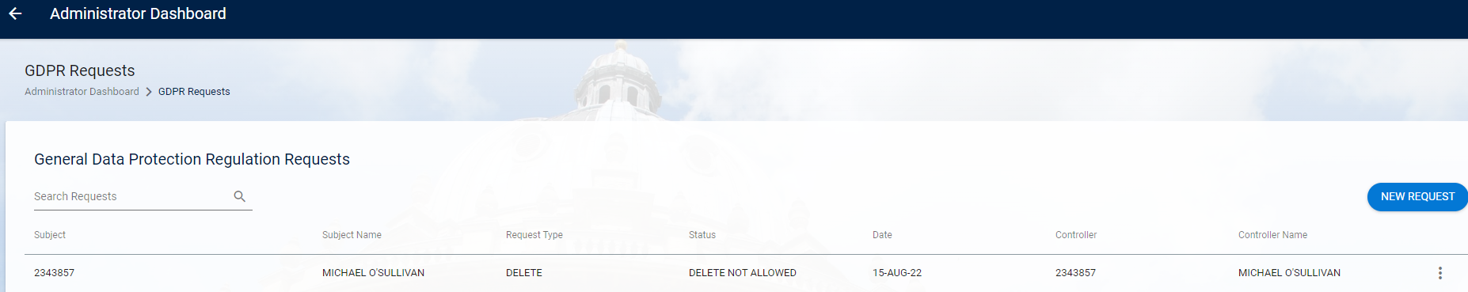

Request Success
The time taken for the request to be processed depends on the range and volume of data recorded for that employee. When the processing begins, the status updated to “PROCESSING!. Once the delete request finishes processing the request is immediately deleted from the GDPR Requests screen.
All traces of the deletion request are removed from PeopleXD and are not retrievable visa the GDPR request Centre. This is completed in accordance with the GDPR regulations. The request may be reported on via Insight, with the employee details redacted.

Deleting GDPR Requests
Subject Access Requests and failed Deletion requests will remain on the GDPR Requests screen for reference, until cleared down manually or automatically. Automatic clear down is carried out after 30 days, but this is configurable.
Successful deletion requests are immediately deleted from the GDPR Requests screen.
To manually delete a request click on the ellipses button and select Delete.
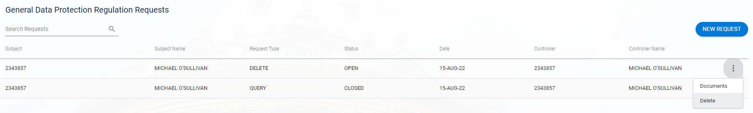

Reporting on GDPR via Insight
The ‘Core GDPR business area is available in Insight to facilitate reporting on GDPR activities. This is intended for use by those users responsible for managing GDPR within the organisation.
This allows reporting on the Activity View, which provides details of the requests submitted through the GDPR Requests Centre. Completed Data Deletion requests are reportable but with the employee reference removed.
Fields available are:
Action | Describes the Action which is in progress, i.e. DELETE OR QUERY
Date Added | Date request made
ID | ID number
Last Updated | Last activity update
Last Updated By | Username of request creator
Status | Status of the request, i.e. CLOSED or DELETE NOT ALLOWED
Subject | Employee Number for the subject of the request
username | Username for who created the request

Example of report within Insight:
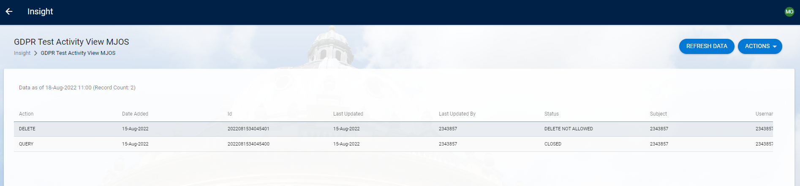

Report GDPR Activity View has been shared with all users who have the GDPR Organisational role assigned, currently restricted to the Functional Analysis team.
